Documentation

Prompt, Get Path of, and open Input File

Prompt, Get Path of, and Create Output File

While there are lines in the input file

Read each line in the Input file

Convert them to uppercase

Store the converted lines in the Output File

Close the Input and Output Files

**Compile Screenshot**

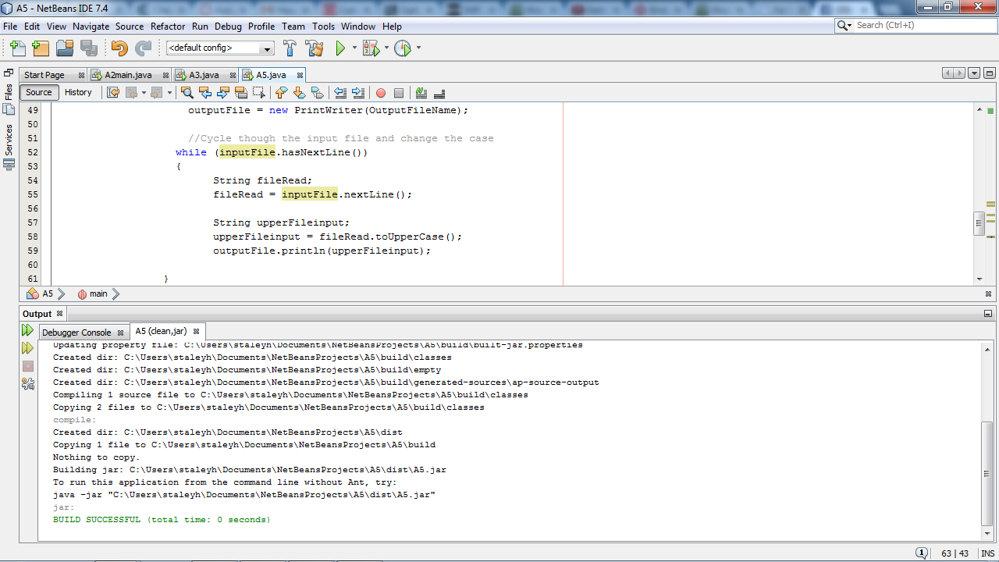

**Run Screenshot**

